**D15B/37** **Mikil Lalwani** **IP Lab 8**

**Aim -**

Experiment to study the basics of React.

**Theory-**

What is React?

React is a free and open-source front-end JavaScript library for building user interfaces based on UI components. It is maintained by Meta and a community of individual developers and companies.

React Feature-

Currently, ReactJS gaining quick popularity as the best JavaScript framework among web developers. It is playing an essential role in the front-end ecosystem. The important features of ReactJS are as follows.

1. JSX
2. Components
3. One-way Data Binding
4. Virtual DOM
5. Simplicity
6. Performance

What are React components?

Components are independent and reusable bits of code. They serve the same purpose as JavaScript functions, but work in isolation and return HTML.

Components come in two types, Class components, and Function components, in this tutorial we will concentrate on Function components.

Function Component-

Here is the same example as above, but created using a Function component instead.

A Function component also returns HTML and behaves much the same way as a Class component, but Function components can be written using much less code, and are easier to understand.

Class Component-

A class component must include the extends React. Component statement. This statement creates an inheritance to React. Component, and gives your component access to React.Component's functions.

The component also requires a render() method, this method returns HTML.

Props-

Components can be passed as props, which stands for properties.

Props are like function arguments, and you send them into the component as attributes.

State-

The state is a built-in React object that is used to contain data or information about the component. A component’s state can change over time; whenever it changes, the component re-renders. The change in state can happen as a response to user action or system-generated events and these changes determine the behavior of the component and how it will render.

**Code-**

App.js-

import logo from './logo.svg';

import './App.css';

import Navbar from './Navbar';

import Content from './Content';

function App() {

return (

<div>

<Navbar />

<Content />

</div>

);

}

export default App;

Navbar.js -

import "./Navbar.css";

function Navbar() {

return (

<div class="navi">

<nav class="nav1">

<p class="navelem1">Home</p>

<p class="navelem1">Contact</p>

<p class="navelem1">About us</p>

</nav>

<nav class="nav2">

<p class="navelem1">Login</p>

<p class="navelem1">Signup</p>

</nav>

</div>

);

}

export default Navbar;

Content.js-

import React from "react";

import { Component } from "react";

import './Content.css'

class Content extends React.Component {

render() {

return (

<div class="content">

<table class="table1">

<tr>

<td class="header">Sr No.</td>

<td class="header">Name</td>

<td class="header">Contact</td>

<td class="header">Email</td>

</tr>

<tr>

<td>1</td>

<td>Achit Kimberlin</td>

<td>(897) 798-2418</td>

<td>ackimberl@progressenergyinc.info</td>

</tr>

<tr>

<td>2</td>

<td>Adelicia Billington</td>

<td>(444) 756-5173</td>

<td>ade-billing@egl-inc.info</td>

</tr>

<tr>

<td>3</td>

<td>Macy Highley</td>

<td>(516) 387-0335</td>

<td>ma-high@egl-inc.info</td>

</tr>

<tr>

<td>4</td>

<td>Adir Duque</td>

<td>(223) 986-4952</td>

<td>adi_du@careful-organics.org</td>

</tr>

<tr>

<td>5</td>

<td>Amsden Kitterman</td>

<td>(329) 844-2810</td>

<td>am.kitterman@egl-inc.info</td>

</tr>

<tr>

<td>6</td>

<td>Nellwyn Highley</td>

<td>(926) 365-8184</td>

<td>ne.highl@acusage.net</td>

</tr>

<tr>

<td>7</td>

<td>Nigel Giffin</td>

<td>(805) 567-1148</td>

<td>nigel.giffin@careful-organics.org</td>

</tr>

</table>

</div>

);

}

}

export default Content;

**Screenshots-**

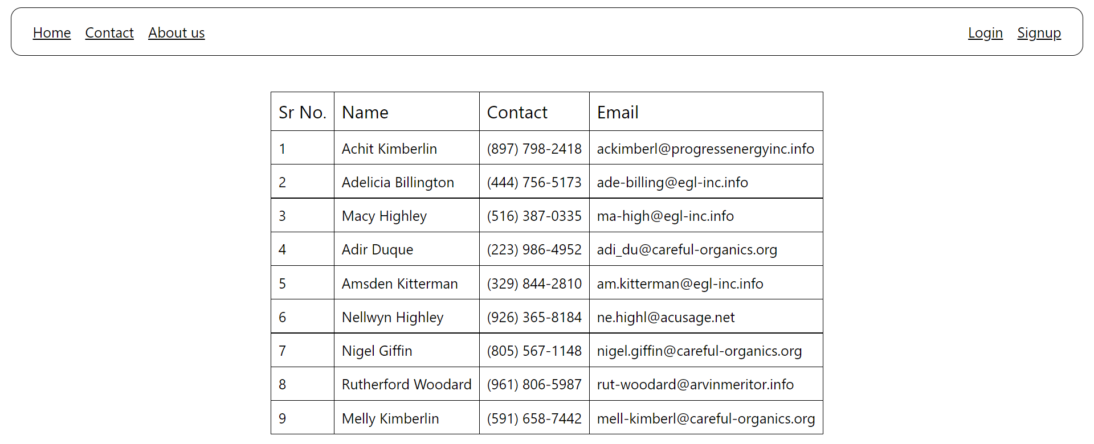

**Conclusion-**

We have successfully completed the experiment.